**Project Documentation: Personal Portfolio**

# Overview:

Welcome to my Personal Portfolio! This portfolio showcases my skills, projects, and achievements. It's designed to provide visitors with insights into my professional journey and expertise. Whether you're a potential employer, collaborator, or just curious about my work, this portfolio serves as a comprehensive glimpse into my capabilities.

# Technologies Used:

## Frontend:

**HTML5:** Used for structuring the content of the website.

**CSS:** Responsible for styling and layout design, ensuring a visually appealing experience.

**JavaScript:** Implemented for dynamic and interactive elements, enhancing user engagement.

**Hosting:**

**[Hosting Service]:** GitHub:

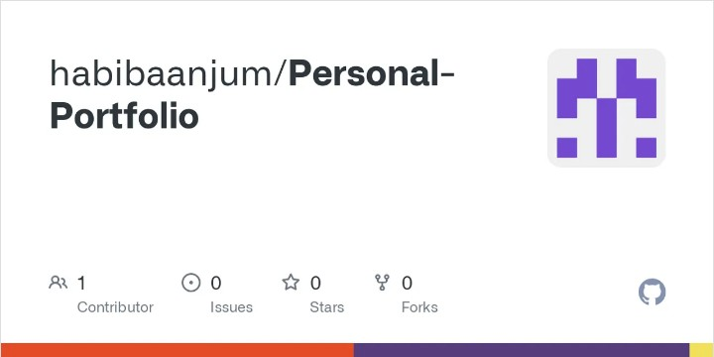

# How to Navigate:

## Home:

The landing page provides a brief introduction and sets the tone for the entire portfolio.

## About Me:

Navigate here to learn more about my background, skills, and professional journey.

## Facts:

Explore my interest in other areas.

## Skills:

Explore my skills on which I had worked on.

## Resume:

This section showcase the summary of my four journey.

## Portfolio:

Explore the area on which I had worked on.

## Contact:

Find my contact information and reach out to me for inquiries, collaborations, or just to say hello!

# Additional Features:

## Responsive Design:

This portfolio is designed to be accessible and visually appealing on various devices, ensuring a seamless user experience.

## Dynamic Content:

Interactive elements and dynamic content enhance user engagement and provide an immersive exploration experience.

## Version Control:

The project is maintained using version control (Git), allowing for easy collaboration and tracking of changes.

Feel free to explore, and thank you for visiting my Personal Portfolio!